DATA STRUCTURES AND ALGORITHMS LAB ASSIGNMENT – 5
Student Details
- Name: Pratyush Deo Singh
- Registration Number: 25BCE5101
- Course / Branch: B. Tech CSE (Core)
- Semester: 2nd
- Subject: Data Structures and Algorithms
- Faculty Name: Dr. Malini A

Program 1: Linear Queue (Menu Driven)
Program Code
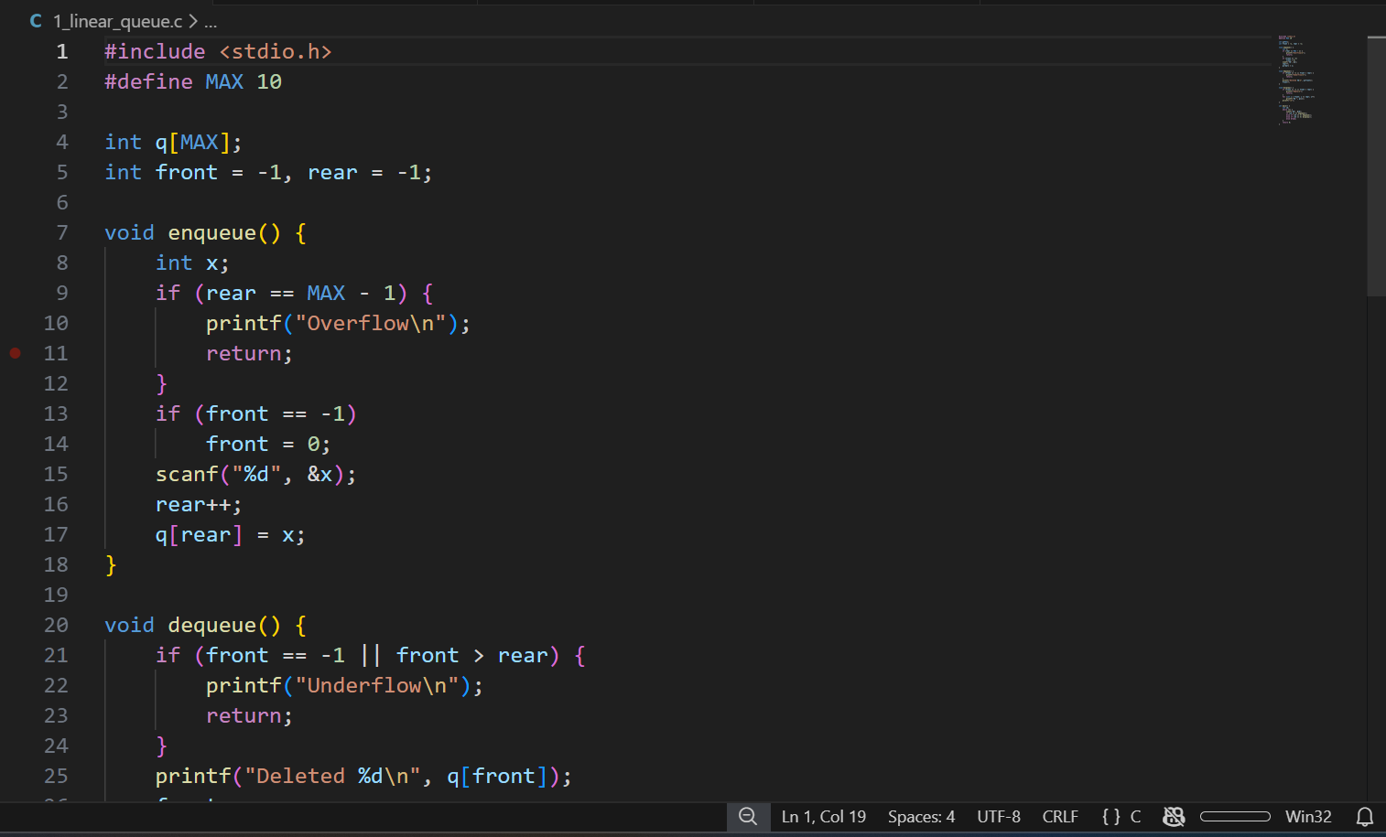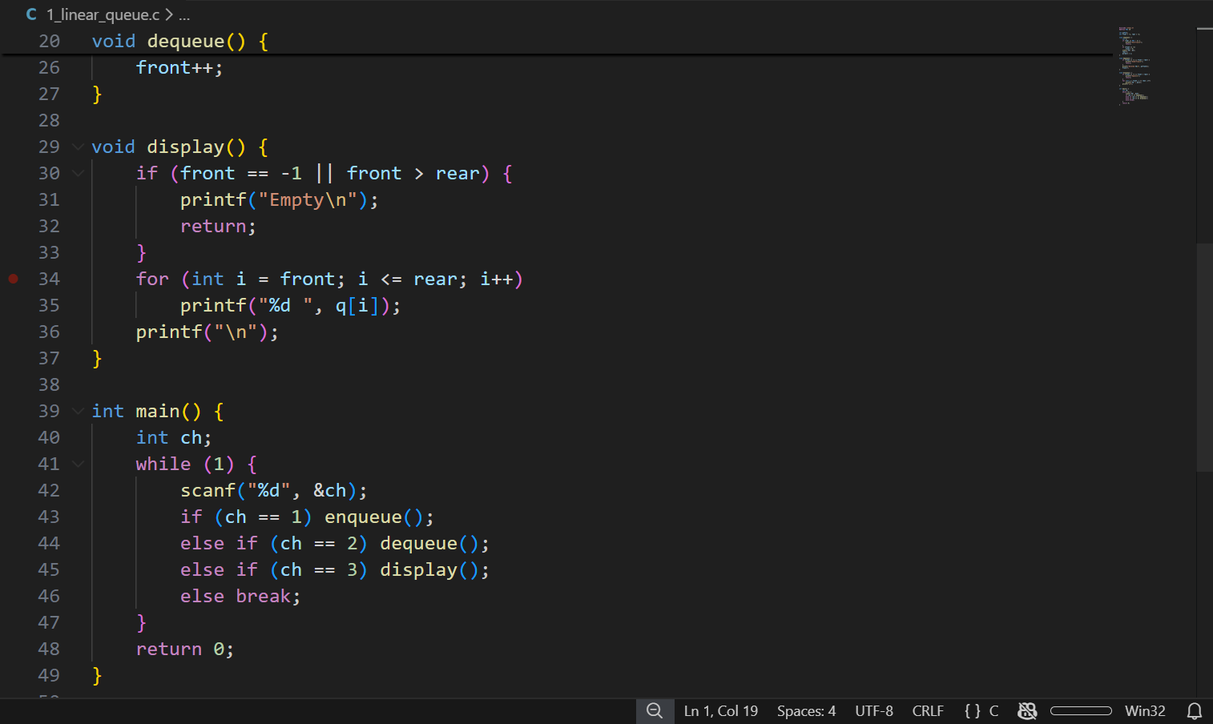

Output
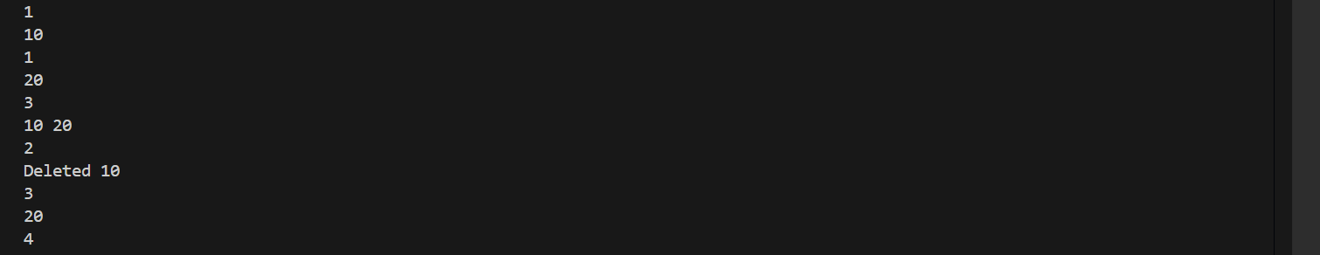
Program 2: Count Elements in Linear Queue
Program Code
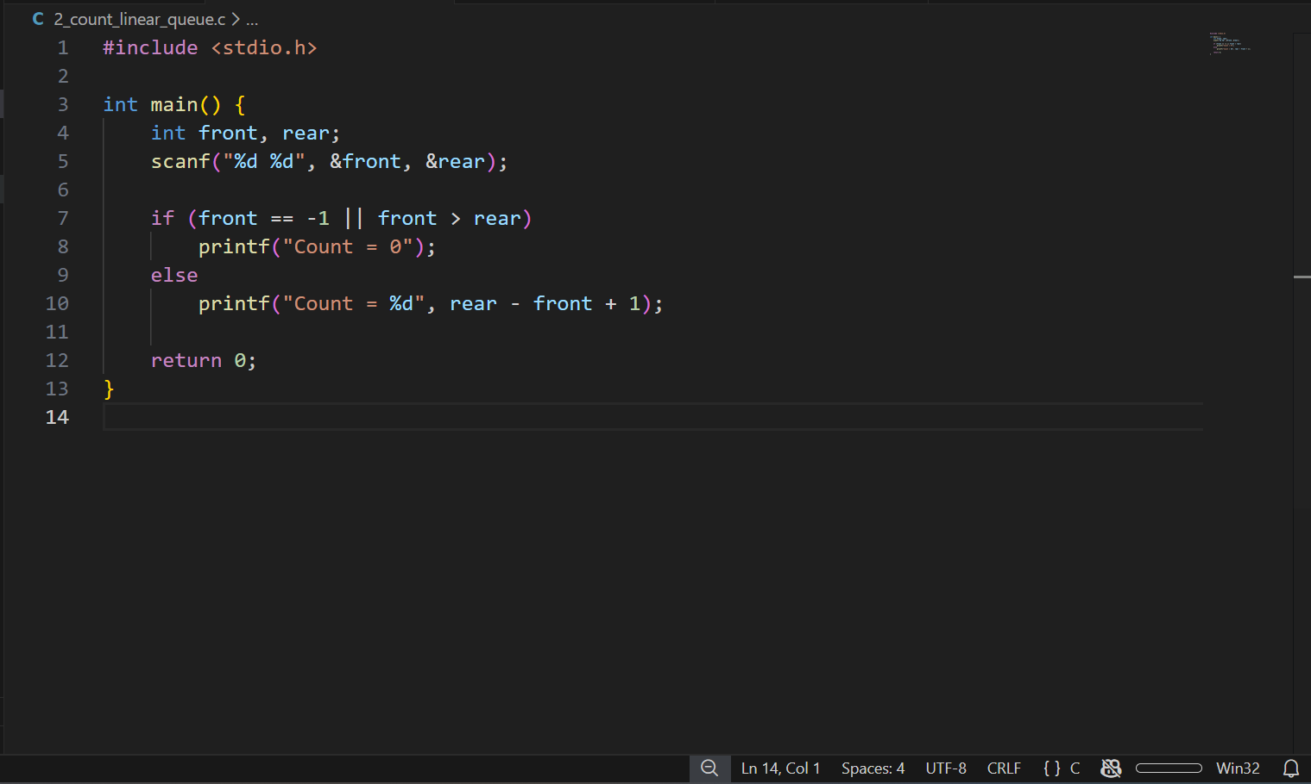Output

Program 3: Reverse Linear Queue
Program Code
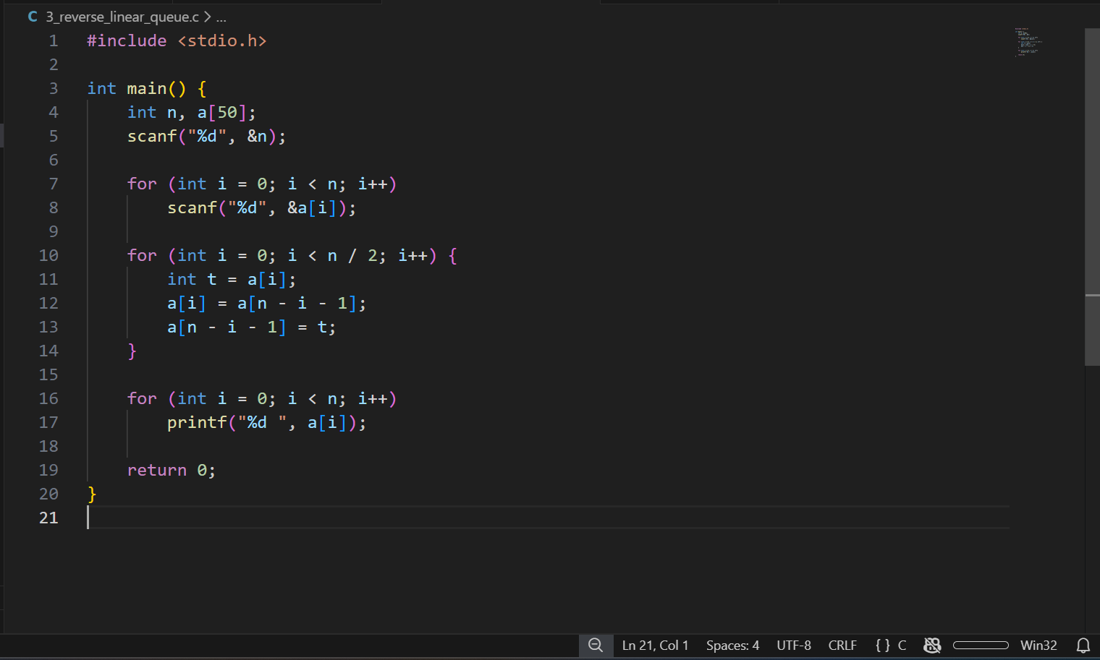Output

Program 4: Circular Queue (Menu Driven)
Program Code
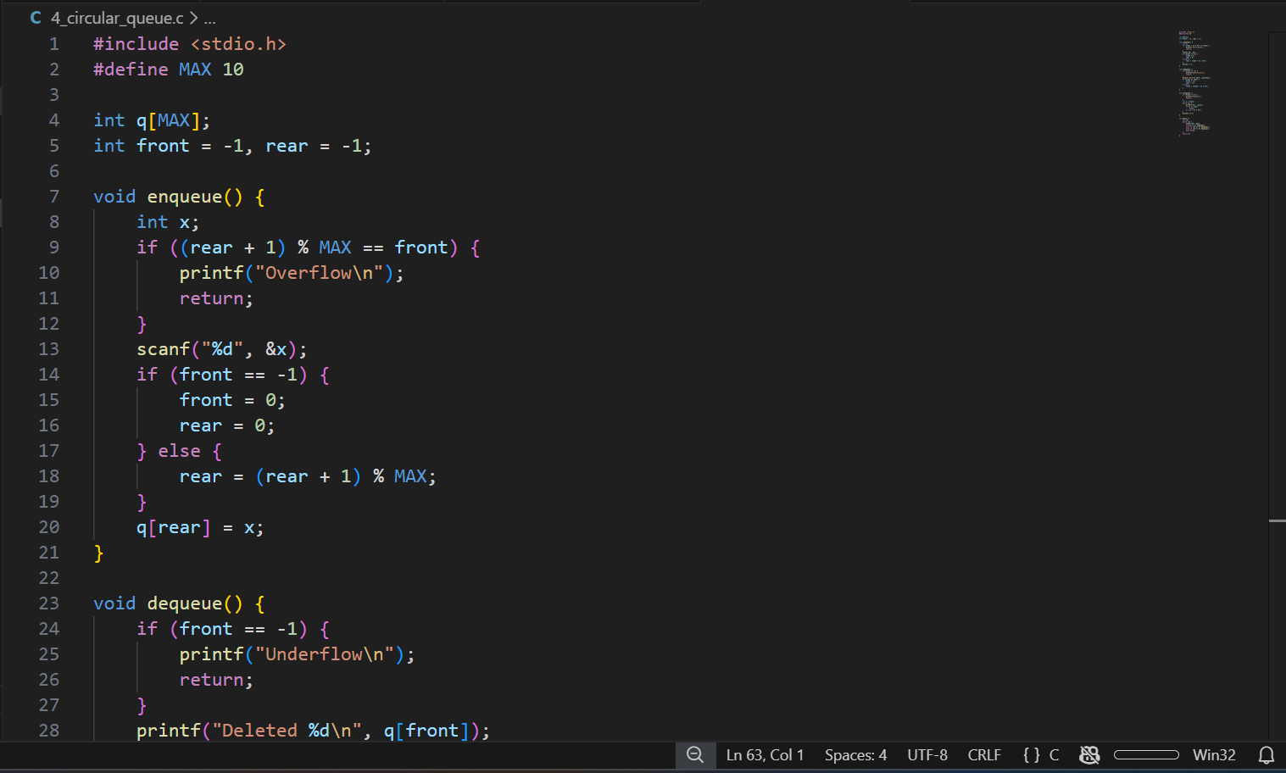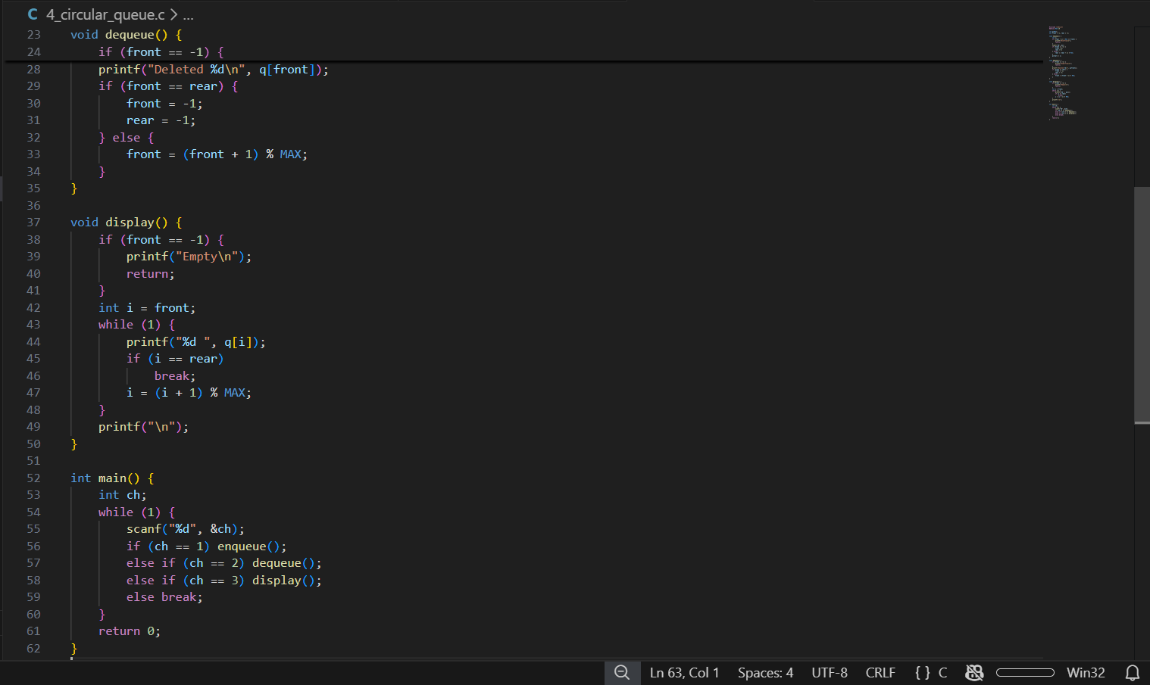

Output
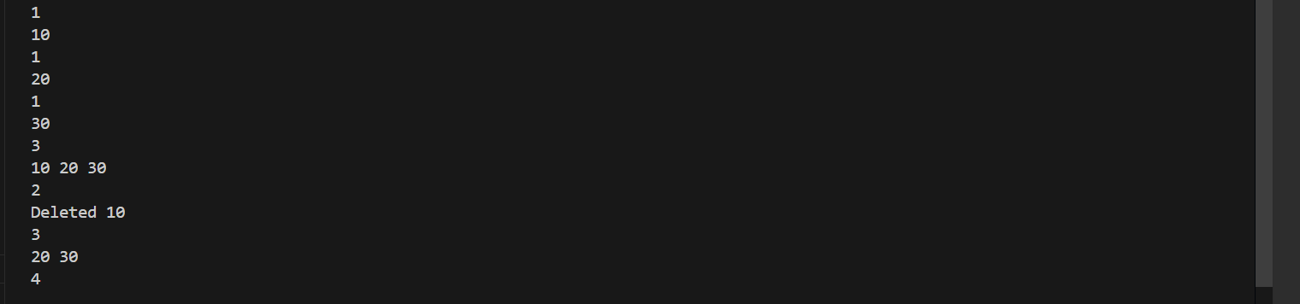
Program 5: Count Elements in Circular Queue
Program Code
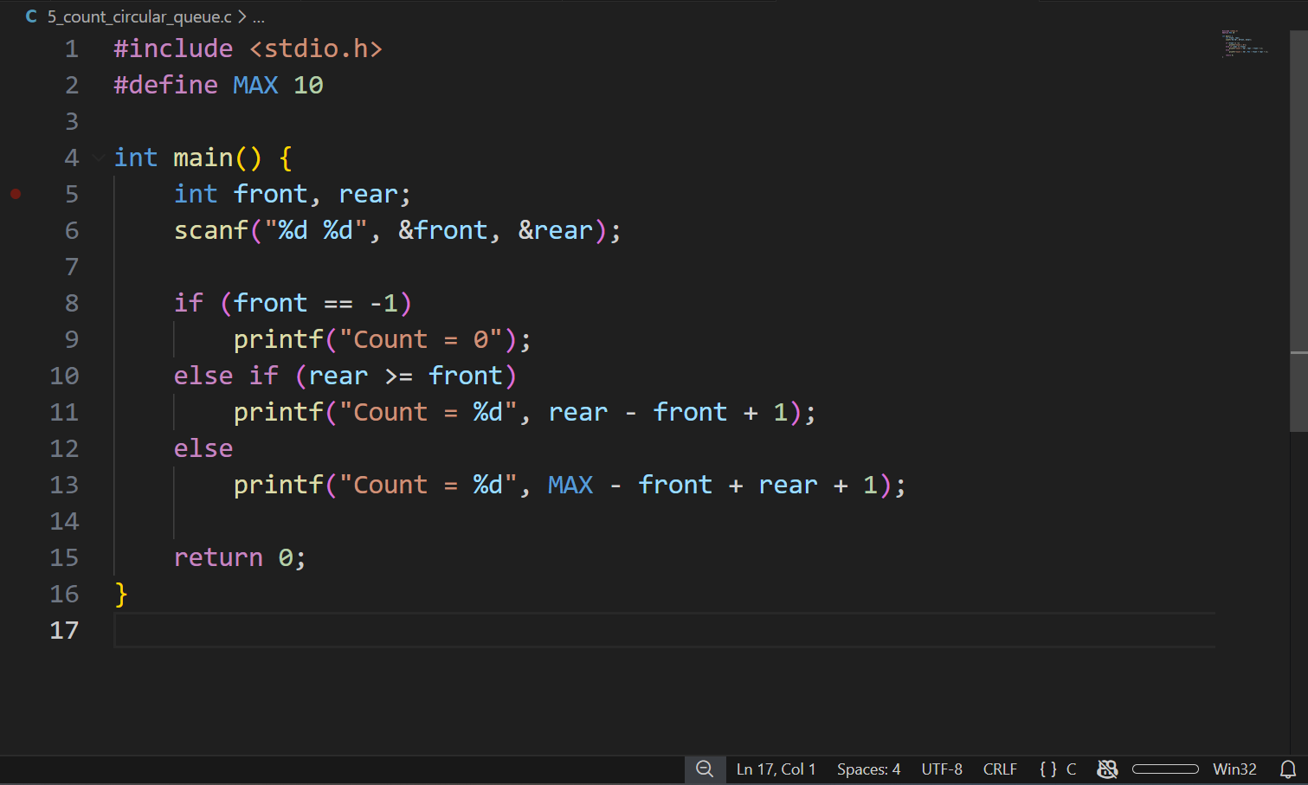Output

Program 6: Reverse Circular Queue
Program Code
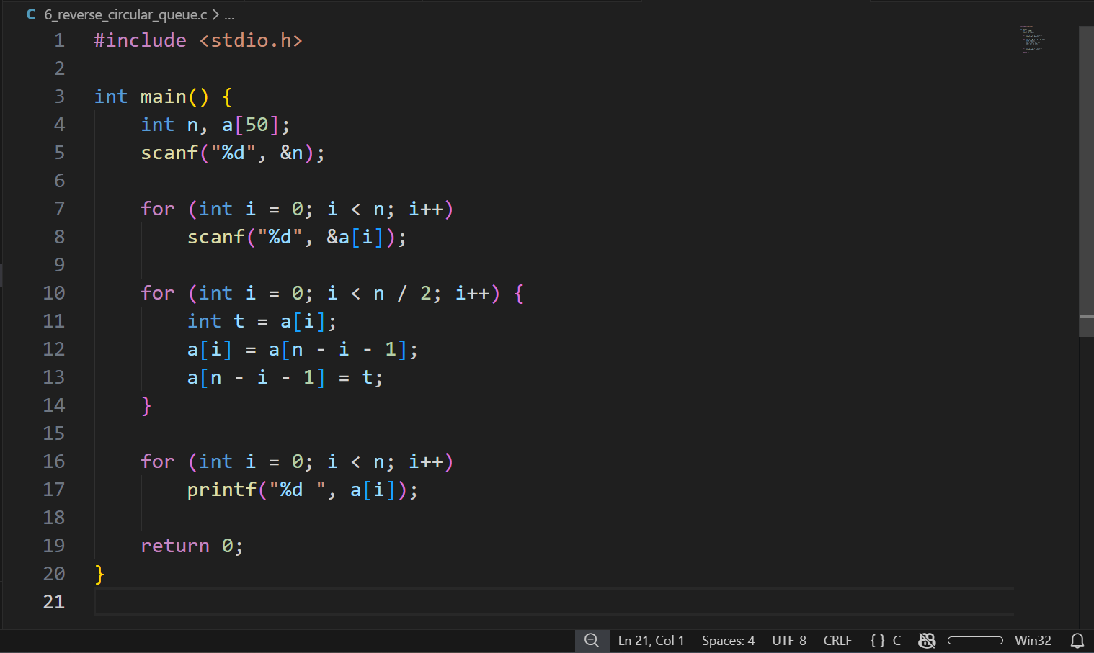Output

Program 7: Deque using Array (Menu Driven)
Program Code
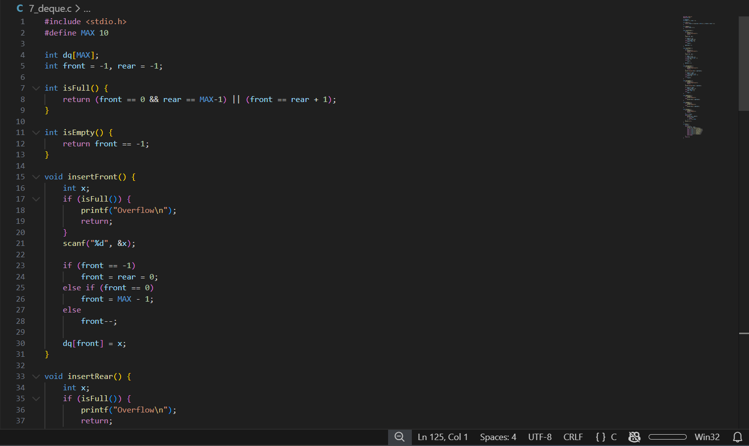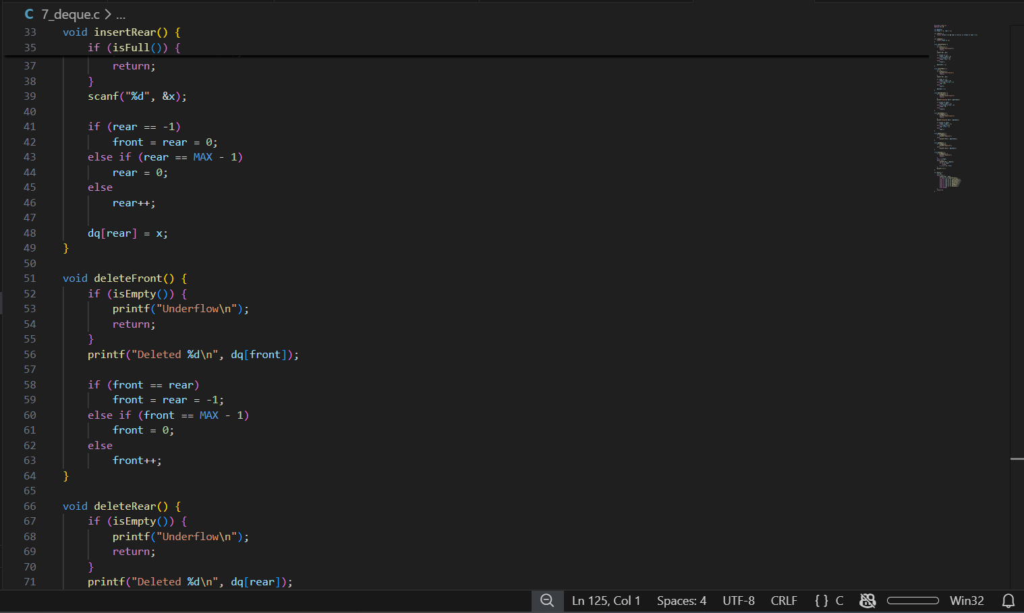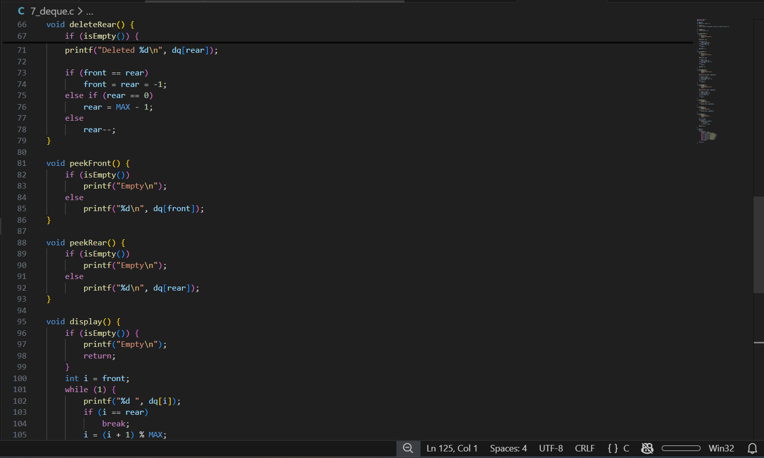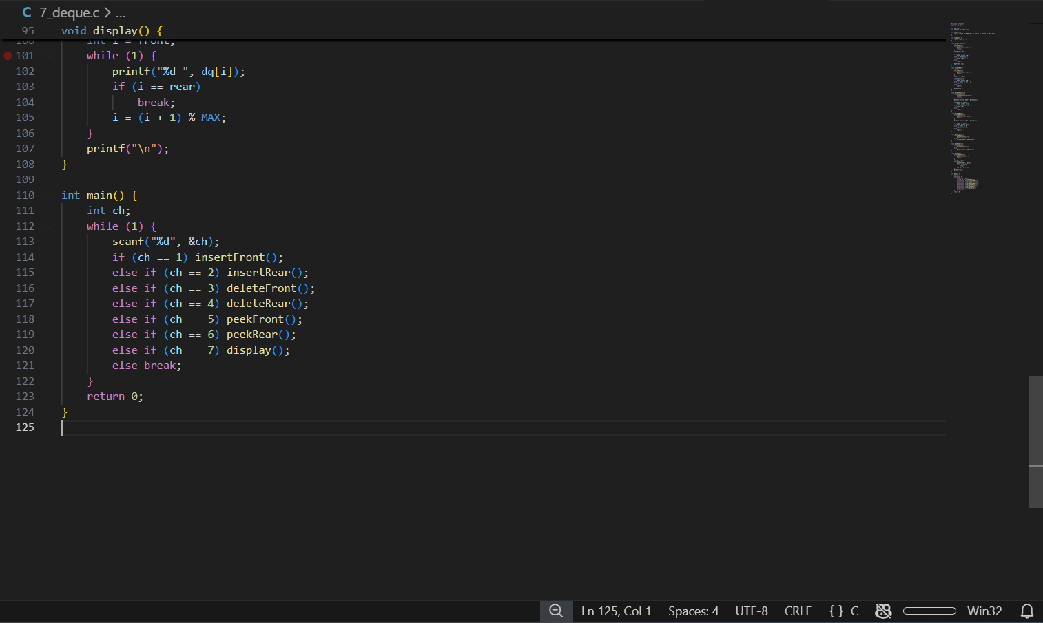Output
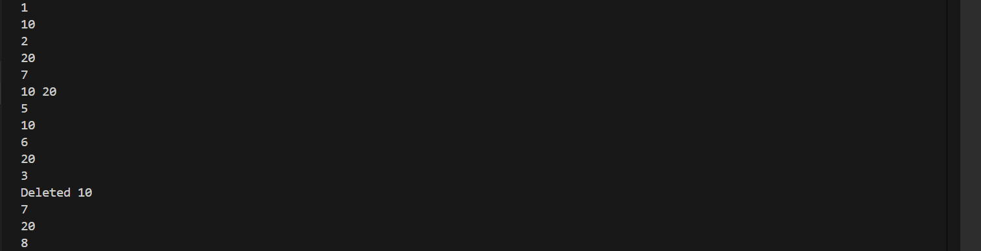
Program 8: Input Restricted Deque
Program Code
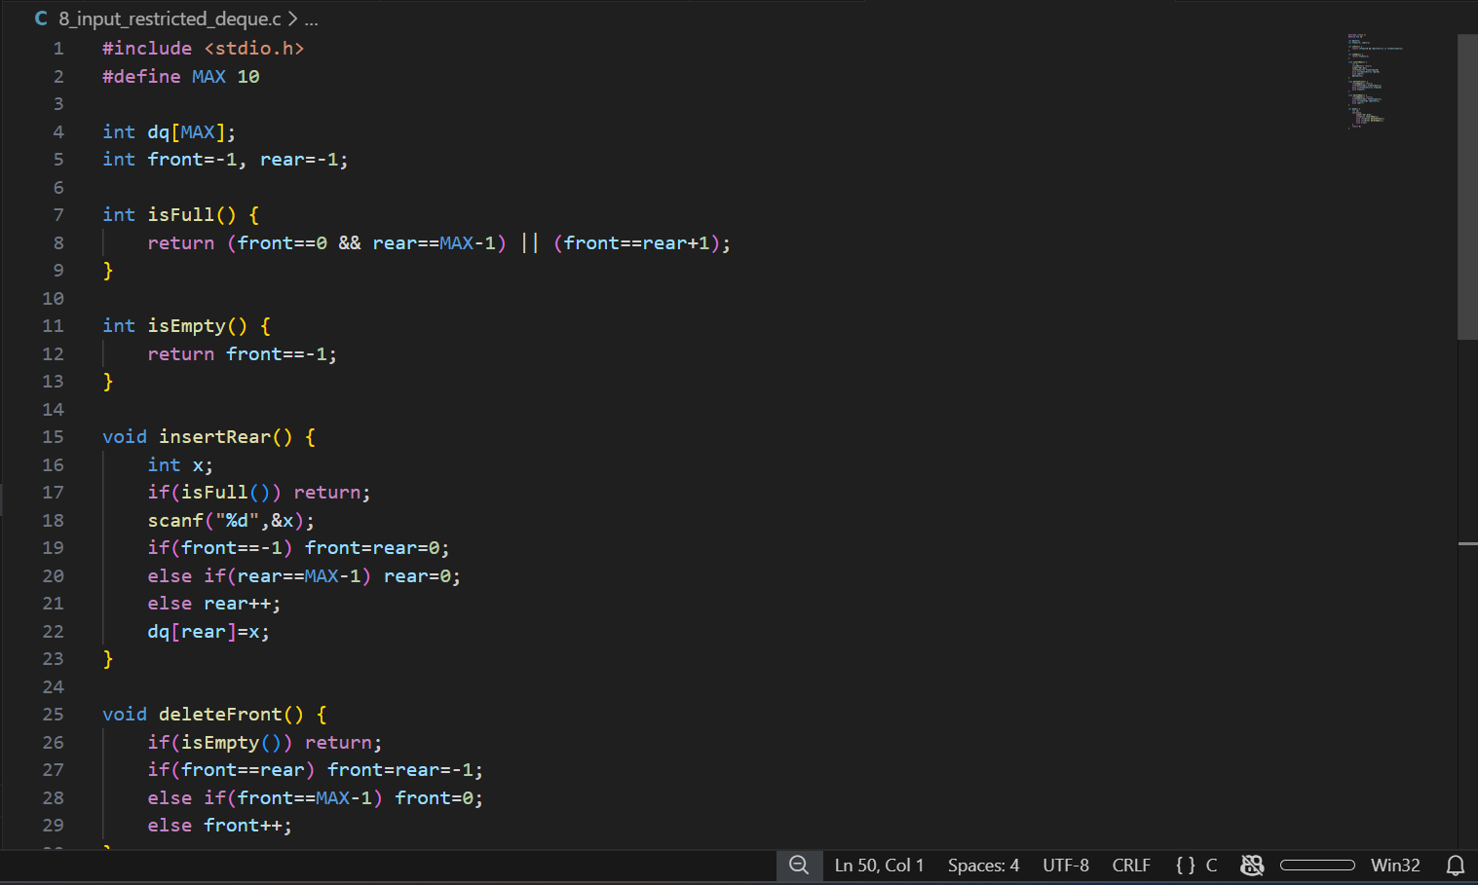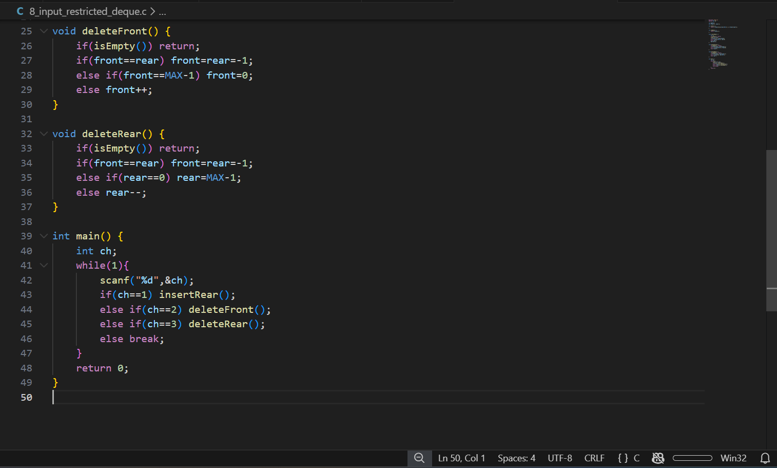Output
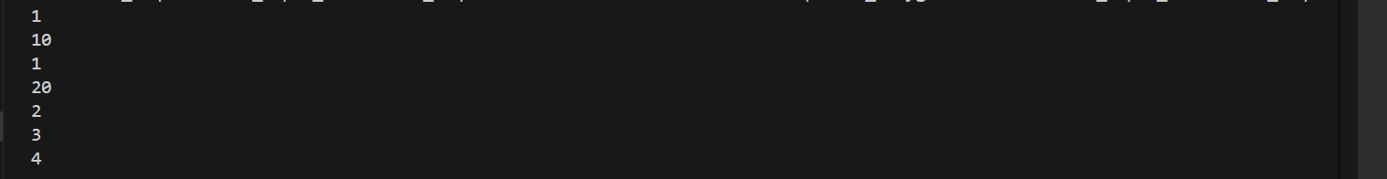
Program 9: Output Restricted Deque
Program Code
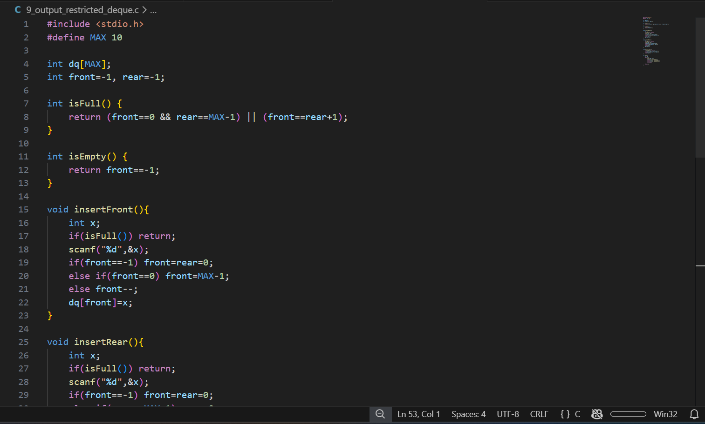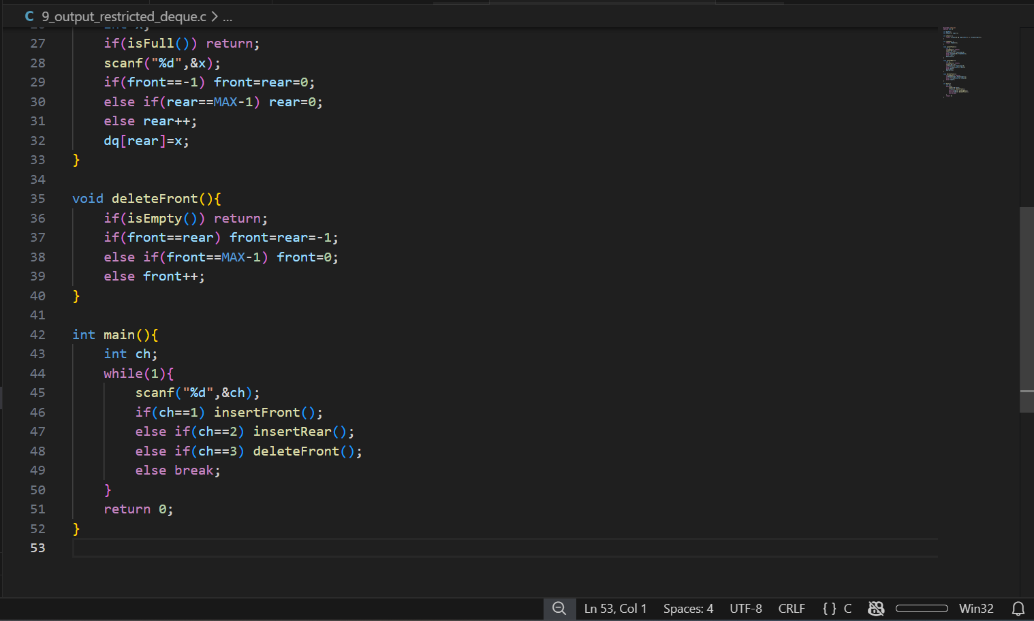Output
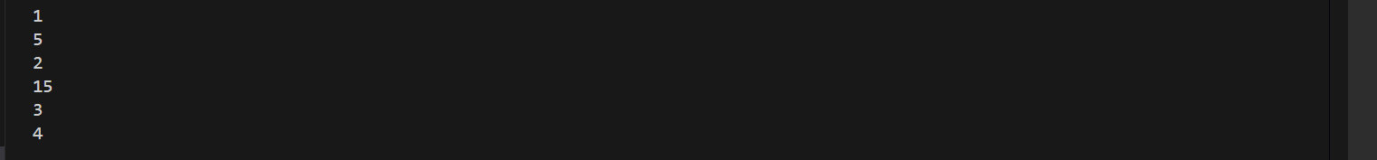
Program 10: Palindrome Check using Deque
Program Code
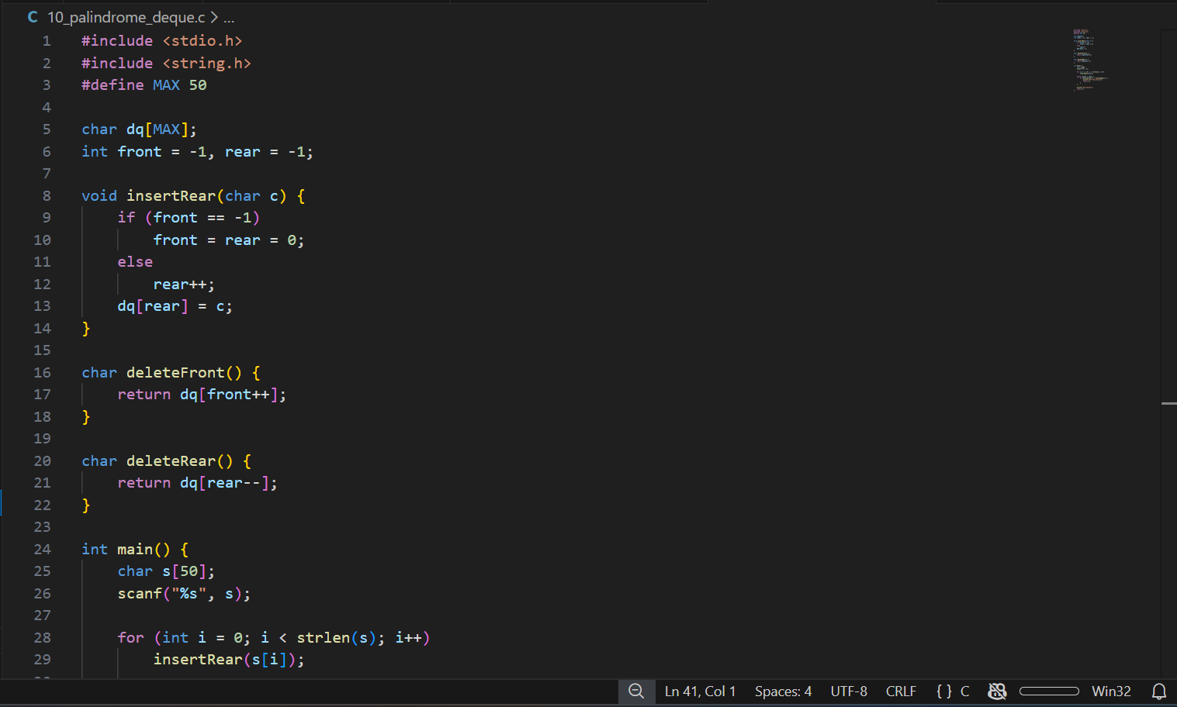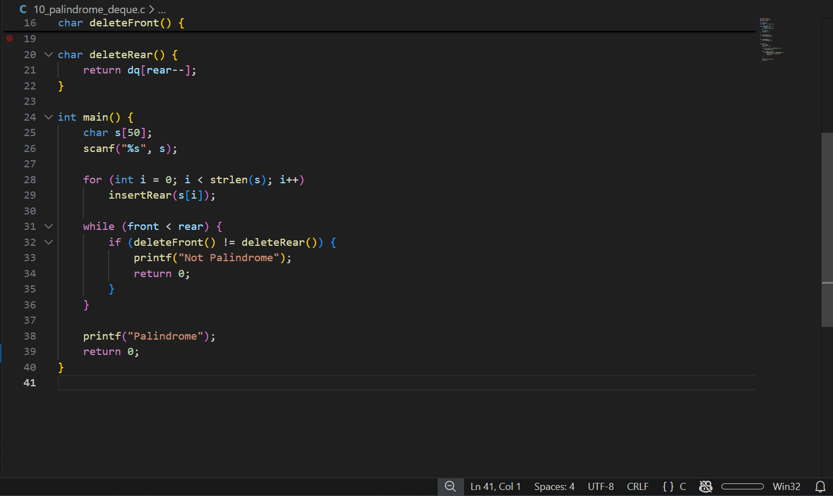Output
Result
All programs were successfully executed and verified.

